Exercises
Complete the exercises assigned by your instructor by drawing the required models. Save each diagram. Copy and paste the diagrams into this document. Save this document to your home directory. Close this document. Attach this document to the Lab 4 Assignment in Bright Space and submit the assignment in Bright Space.
- Using the use case narrative KEY from Lab 3 for the Employee Equipment Checkout System (#9), create an activity diagram.
Answer: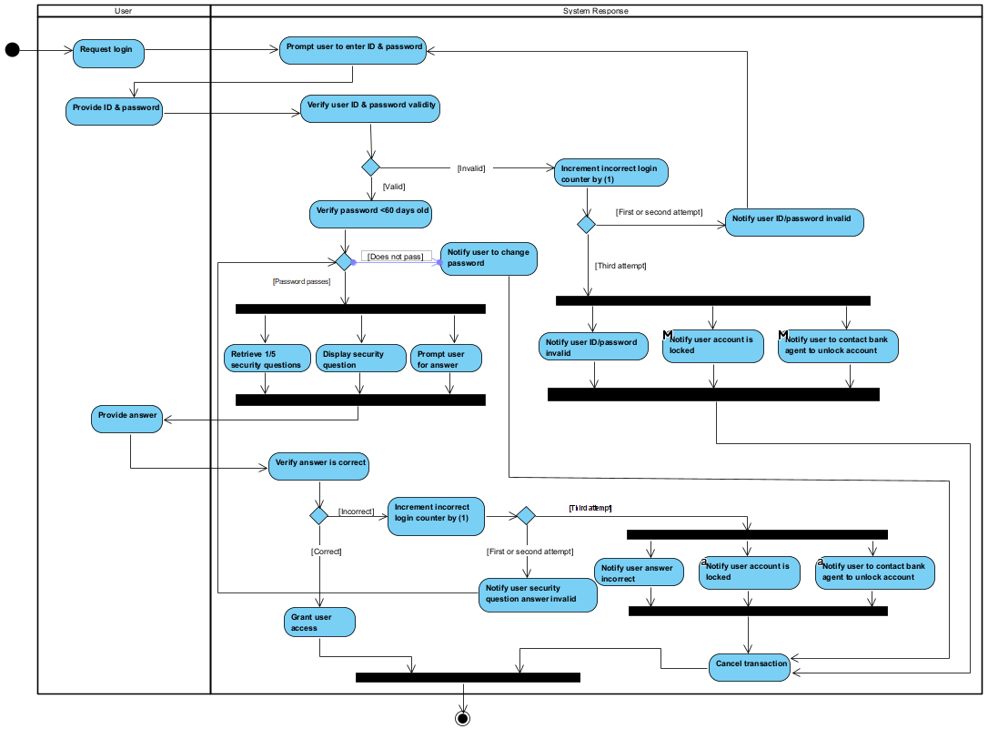
- Using the narrative below, create an activity diagram.

A customer makes an appointment with an eye doctor. The eye doctor performs an examination. The eye doctor prepares the prescription. The customer goes to the eye glasses store. The customer selects the frame. The customer selects the lenses. The eye glass store constructs the glasses. The customer tries them on. If they fit the customer pays for them and goes home. If they don’t fit, the eye glasses store adjusts the fit and the customer tries them back on. The previous step is repeated until the glasses fit.
Answer:
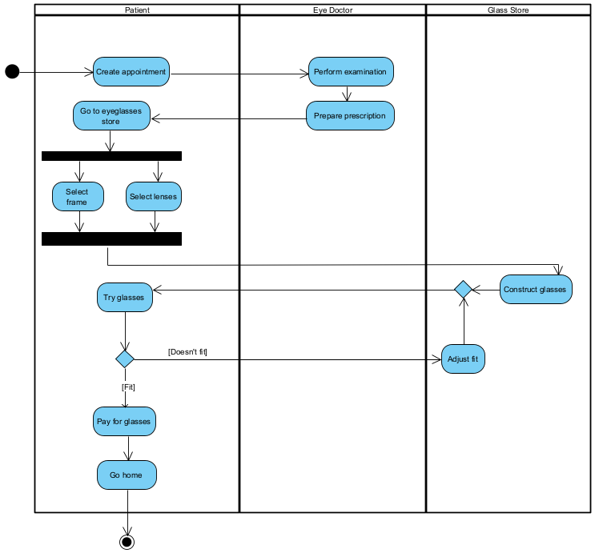
- Using the use case narrative below, create an activity diagram.

ATM System

Author: Barlow, Victor M. Date: 08/11/2015

Use-Case Name: | Make ATM deposit to checking account |  | Use Case Type  Business Requirements: ☑  System Analysis: □  System Design: □
Use-Case ID: | Lab 4 – Problem 4
Priority: | Normal
Source: | Lab Manual
Primary Business Actor: | Patron
Primary System Actor:
Other Participating Actors:
Other Interested Stockholders: | ATM Manager
Description: | A patron arrives at the ATM machine with the intention to make a deposit. The ATM requests the card, PIN, deposit amount, deposit envelope, and then dispenses a receipt & the card.
Precondition: | The patron has a valid ATM card and PIN and open checking account.
Trigger: | The patron inputs their ATM card into the ATM machine.
Typical Course Of Events: | Actor Action | System Response
 | STEP 1: The patron inputs their ATM card (containing their account #) into the ATM machine. | STEP 2: The system verifies that the card is valid.
 |  | STEP 3: The system prompts for the PIN.
 | STEP 4: The patron inputs their PIN. | STEP 5: The system verifies the PIN is valid for the account number on the card.
 |  | STEP 6: The system prompts the user for the type of transaction desired.
 | STEP 7: The patron selects DEPOSIT. | STEP 8: The system prompts the patron to enter the amount to be deposited.
 | STEP 9: The patron inputs the deposit amount. | STEP 10: The system prompts the patron to enter the deposit envelope.
 | STEP 11: The patron enters the deposit envelope containing the deposit. | STEP 12: The system logs the transaction, updates the patron’s account, marks the envelope, (the previous three actions are done at the same time),
 |  | STEP 13: System dispenses the card and a receipt.
 | STEP 14: The patron takes the card & receipt and leaves.
Alternate Courses: | ALT-STEP 2a: The card is NOT valid, notify patron  ALT-STEP 2b: Cancel the transaction.  ALT-STEP 5: The PIN is NOT valid for that card, GO TO STEP 3.
Conclusion: | This use case concludes when the deposit has been completed and the patron receives their card & receipt.
Postcondition: | The deposit has been recorded.
Business Rules:
Implementation Constraints and Specifications:
Assumptions:
Open Issues:

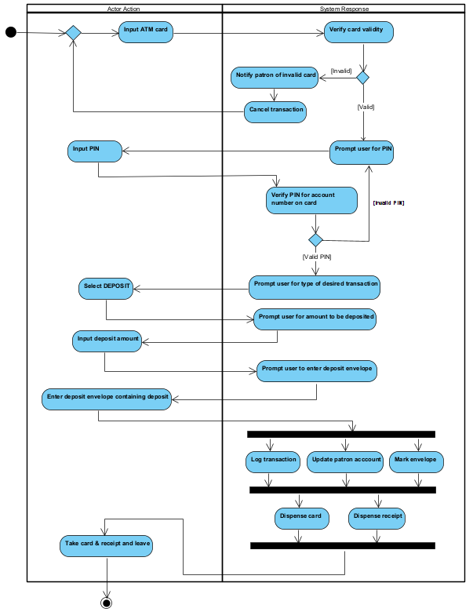
- From the example provided in the slides, expand the activity of “validate credit card” into its own diagram. Make assumptions as to what actors are involved, as well as what the specific actions and decisions can be.
